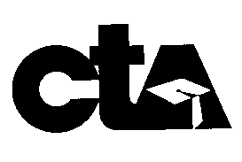
AEEA Declaration of Candidacy Form

Name: ________________________________ Work Location/School: ___________________

I hereby declare that I am a member in good standing of CTA/NEA and AEEA. Select position below. I am a candidate for:

Secretary 2022-2024
Treasurer 2022-2024
NEA-RA 2022 Local Delegate
Director 2022-2024
CTA State Council 2022-2025

CTA State Council Alternate 2022-2025

___________________________________ _______________________________
(Signature of Candidate) (Date)

___________________________________________ ______________________________________
(Contact Number on March 30, 2022) (Name of Observer, if requested)

THIS FORM IS DUE IN THE AEEA/AE OFFICE NO LATER THAN MONDAY, MARCH 14, 2022 @4:00 p.m.

INCLUDE BELOW OR ATTACH A SEPARATE CANDIDATE STATEMENT OF QUALIFICATION. (100 word maximum) YOUR STATEMENT MAY ALSO BE EMAILED TO RONDA MARTINEZ, ANAHEIM EDUCATORS OFFICE MANAGER. (ronda.ae@gmail.com)

MAKE SURE YOUR STATEMENT IS WITHIN THE 100 WORD MAXIMUM. YOUR STATEMENT WILL BE PRINTED AS SUBMITTED UP TO 100 WORDS. AEEA IS NOT RESPONSIBLE FOR MISSPELLINGS OR INCORRECT PUNCTUATION.
CANDIDATES ARE LISTED ON BALLOT ACCORDING TO THE CTA ALPHABET.
Elections count to take place at the Anaheim Educators office on Wed., March 30, 2022.

